Medical Centre | Dr K Vijayan (GMC No. 3608487)  Dr K Malathy (GMC No. 4078551)  Dr R Shrouder (GMC No. 3614576)  www.millviewmedicalcentre.co.uk

Dear Patient

NEW PATIENT REGISTRATION

Welcome to Millview Medical Centre, the Partners and staff are pleased that you have chosen to register with our Practice.

For your information, our practice is located across two sites, the contact details are at the bottom of this letter.

For your convenience, we have produced this patient registration pack which contains all the required documentation to ensure your registration is straightforward.

Contents

- NHS GMS1 - Family doctor services registration.
- Confidential Registration Questionnaire - Please complete and include the required proof of identity/address.
- Patient Leaflet - Details our services.
- Privacy Information Leaflet
- Online Access.
- Text Service Consent - Sign up for Text alerts for appointment reminders.
- NHS Summary Care Record - Information and details of how to opt-out.

Please return all the required documents along with some proof of identity/address to reception at either site.

The Partners and Staff at Millview Medical Centre.

CONFIDENTIAL REGISTRATION

Medical Centre QUESTIONNAIRE
To assist the practice in providing good medical care, please complete the following details and return to Reception with your registration document and proof of identification and address. If you would like to register for online facilities, please ask at Reception.
PERSONAL INFORMATION
TITLE (please delete as appropriate) | MR/MRS/MS/MISS/(other):
FIRST NAME(S)
SURNAME
DATE OF BIRTH
TELEPHONE: HOME
TELEPHONE: WORK
TELEPHONE: MOBILE
EMAIL ADDRESS

MEDICATION INFORMATION (ATTACH LAST REPEAT PRESCRIPTION)
Are you allergic to any medications (e.g. penicillin), please state:

Do you have any allergies (e.g. pollen, eggs), please state:

Are you taking any PRESCRIBED MEDICATIONS/TABLETS at present?
DRUG | STRENGTH (mg) | DOSE

OTHER INFORMATION
So far as you are aware, are you currently on any waiting list within the NHS for any operations or outpatients appointments? YES / NO
If YES, please provide the following information if possible: hospital, department, consultant and any operation or procedure awaited (including the hospital number if known):

PLEASE MAKE APPOINTMENT(S) FOR A NEW PATIENT HEALTH CHECK /MEDICATION REVIEW AS SOON AS P

If you are on any regular repeat medication please make staff aware if you will run out before your New Patient Medical.
The information I have provided is correct and I apply to be included on the list of the Practice. I acknowledge receipt of an offer for medical examination/repeat medication review.

Signed: | Date:

Millview Medical Centre Millview Medical Centre
Heckington Surgery contact : 01529 460213 Sleaford Surgery contact : 01529 305595
CONSENT/PERMISSION CONFIDENTIALITY FORM
FOR a CARER or PERSON GIVEN CONFIDENTIALITY PERMISSION

Dear Patient,
Our Practice is committed to maintaining Patient Confidentiality and will only give patient information and results to you the patient. If you would like us to give information about your Healthcare to a relative or carer – please confirm your consent/permission by completing the details below.

PATIENT NAME …………………………………………………………………….. DATE OF BIRTH……………….………………….
PATIENT NHS NUMBER ………………………………………………………….
PATIENT ADDRESS…………………………………………………………………………………………………………………………………

………………………………………………………………………………………………TELEPHONE :……………………………………….…

DO YOU PREFER TELEPHONE CONTACT BY US ONLY TO YOUR AUTHORISED PERSON - Yes / No…………….
IF YES PLEASE STATE WHY: eg Hard of Hearing, Mobility Issues

.........................................................................................................................................................................................

…………………………………………………………………………………………………………………………………………………………

I CONSENT TO INFORMATION ABOUT MY HEALTHCARE BEING GIVEN TO :

NAME OF AUTHORISED PERSON……………………………………………………….DATE OF BIRTH……………………………

ADDRESS………………………………………………………………………………………………………………………………………………..

……………………………………………………………………………………………….TELEPHONE…………………………...................

RELATIONSHIP TO THE PATIENT………………………………………………………………………………………………………………

PASSWORD…………………………………….EMERGENCY CONTACT NUMBER…………………………………………………….

Please make sure that you and the patient both know
this password – information will not be given without it.

PLEASE TELL US WHAT INFORMATION YOU ARE HAPPY FOR US TO DISCLOSE (TICK ALL RELEVANT BOXES ) :
- MEDICATION INFORMATION ONLY
- RESULTS OF INVESTIGATIONS, REFERRALS AND BLOOD TESTS ( EG: PENDING APPOINTMENTS, X-RAYS, ECG, SCANS )
- CONSENT FOR FULL MEDICAL RECORD ACCESS

SIGNATURE OF PATIENT…………………………………………………………………………………………………..

DATE………………………………… ( Please note this consent will be held on your medical record until such time you ask us to remove it. )

FOR OFFICE USE ONLY

Information added to Patient’s Home Page inc which boxes are ticked SIGN……………..………………..DATE......................

Information added to Patient’s Groups & Relationships Page SIGN………………….……………..DATE…………..………

Medical Centre
Patient Care Text Messaging Service Declaration of Consent/Decline Form
Millview Medical Centre would like to introduce sending SMS text messages to your mobile phone to remind you of any appointments that you have booked at the surgery.
This service may also in the future extend to sending other health information out to you by SMS text such as, texts to let you know your results are back or information about special clinics that we are running such as flu clinics.
The SMS text service should not be solely relied upon, the responsibility of attending appointments or cancelling them still rests with you. You can cancel the text message facility at any time.
The surgery does not offer a reply facility to enable patients to respond to texts directly.
The text messages are generated using a secure system however, they are transmitted over a public network on to a personal telephone and as such are not secure. The practice will not transmit any information that would enable an individual patient to be identified.
Please tick as appropriate:
I Consent to the practice contacting me by text message for the purposes of health
Information, for appointment reminders and for patient feedback.

I Decline to the practice contacting me by text message for the purposes of health
information and for appointment reminders.

I also agree to advise the practice if my mobile number changes or if this is no longer in my possession to keep my records up to date.
Patient Name |  | Signature
Mobile Number to be Used
Date of Birth |  | Date

*The practice does not share mobile phone contact details with any external organisation.

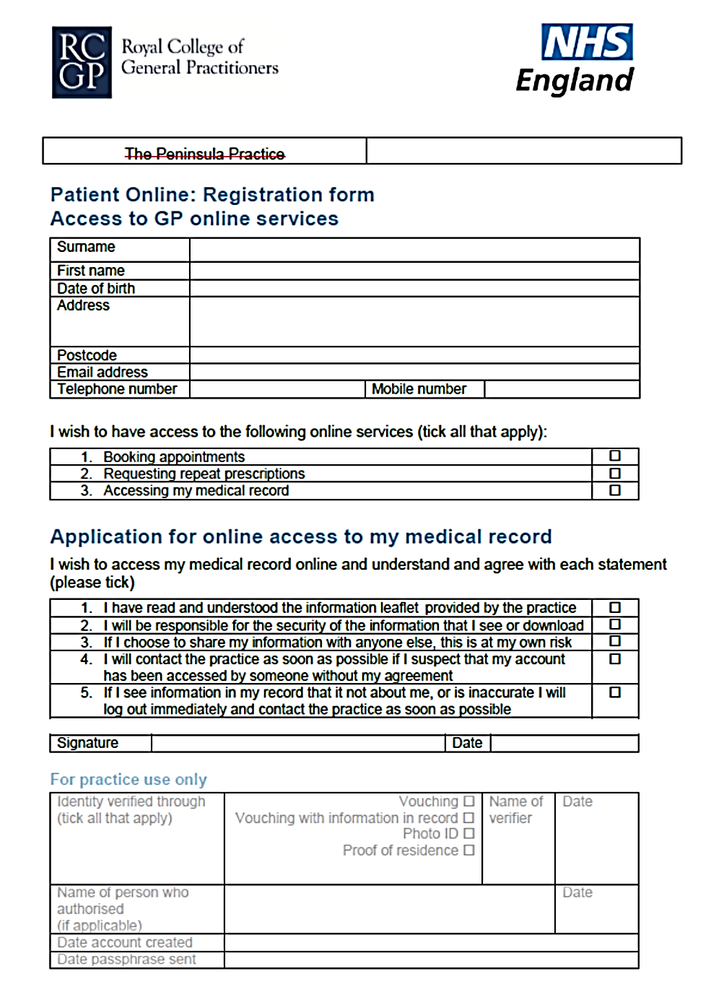
MILLVIEW MEDICAL CENTRE

Medical Centre

Information for new patients: about your Summary Care Record :
Dear patient, If you are registered with a GP practice in England, you will already have a Summary Care Record (SCR), unless you have previously chosen not to have one. It will contain key information about the medicines you are taking, allergies you suffer from and any adverse reactions to medicines you have had in the past.
Information about your healthcare may not be routinely shared across different healthcare organisations and systems. You may need to be treated by health and care professionals who do not know your medical history. Essential details about your healthcare can be difficult to remember, particularly when you are unwell or have complex care needs.
Having a Summary Care Record can help by providing healthcare staff treating you with vital information from your health record. This will help the staff involved in your care make better and safer decisions about how best to treat you.

You have a choice

You have the choice of what information you would like to share and with whom. Authorised healthcare staff can only view your SCR with your permission. The information shared will solely be used for the benefit of your care.
Your options are outlined below; please indicate your choice on the form overleaf.
- Express consent for medication, allergies and adverse reactions only.
You wish to share information about medication, allergies for adverse reactions only.

- Express consent for medication, allergies, adverse reactions and additional information.
You wish to share information about medication, allergies for adverse reactions and further medical information that includes: your illnesses and health problems, operations and vaccinations you have had in the past, how you would like to be treated (such as where you would prefer to receive care), what support you might need and who should be contacted for more information about you.

- Express dissent for Summary Care Record (opt out).
Select this option, if you DO NOT want any information shared with other healthcare professionals involved in your care.
If you choose this option you need to complete the Opt Out Form on the other side of this page.

You are free to change your decision at any time by informing your GP practice.

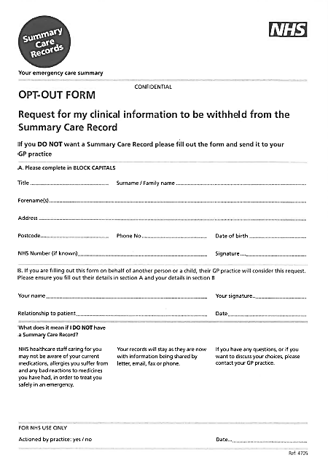

Medical Centre
Sharing your health records
Information about your health and care helps the NHS to improve your individual care, speed up diagnosis, plan your local services and research new treatments.
When you are first or next seen at Millview Medical Centre, you’ll be asked the following questions :
- SHARING OUT : Do you consent to the information that is recorded about you here being made available to other NHS Care Services that care for you and also use Systm One ?

If you answer YES
This means Clinicians at other services that care for you and use Systm One will be able to see your recorded information. For example a district nurse that visits you would be able to see the information recorded by your Doctor.

If you answer NO
The Clinician will be prevented from seeing your information.

- SHARING IN : Do you consent to allow Millview Medical Centre to view information about you that has been recorded by other services where you also receive care ? (You will already have consented to those services to share the information out )

If you answer YES
This Practice will be able to view information recorded on your Patient Record
by other NHS services.

If you answer NO
This Practice will not be able to see any information recorded at any other NHS service.

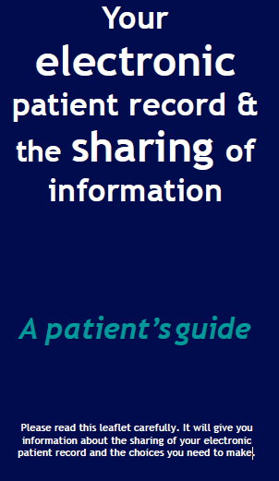
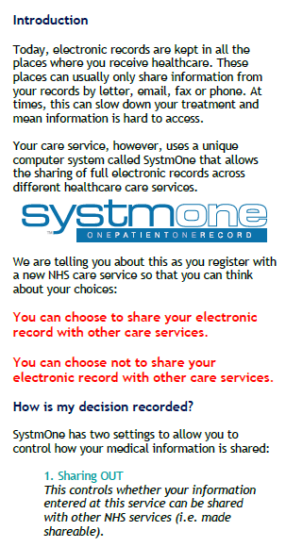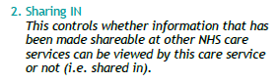
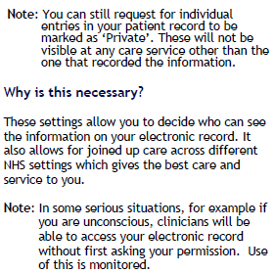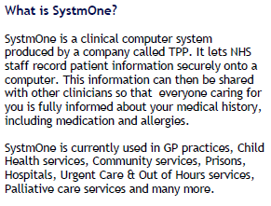
Medical Centre

TO BE COMPLETED BY RECEPTION

Which Chemist
(depending on area)

Textual Appointment Date/Time/Dr/Nurse | Date: Time :  Doctor : Nurse :
Do you have a house  KEY SAFE CODE ? | Code :
Military:  Are you part of the family of a SERVING MEMBER OF THE ARMED FORCES ?  (staff to add read code: XadFb )  Are you Ex Forces ?  ( staff to add veteran read code: XaX3N ) | YES / NO  YES / NO
If Ex Forces:  Enlistment and Discharge Date | Enlistment:  Discharge:
If from Abroad, Date Entered UK and Where Born
Marital Status
Main Language
Next of Kin, Name and Contact details | Name:  Telephone number:  Relationship to Patient:  Address:

Privacy Information leaflet

01529 4

What is a privacy notice?
A privacy notice is a statement that discloses some or all of the ways in which the practice gathers, uses, discloses and manages a patient’s data. It fulfils a legal requirement to protect a patient’s privacy.

Why do we need one?
To ensure compliance with the General Data Protection Regulation (GDPR), Millview Medical Centre must ensure that information is provided to patients about how their personal data is processed in a manner which is:
- Concise, transparent, intelligible and easily accessible;
- Written in clear and plain language, particularly if addressed to a child; and
- Free of charge

What is the GDPR?
The GDPR replaces the Data Protection Directive 95/46/EC and is designed to harmonise data privacy laws across Europe, to protect and empower all EU citizens’ data privacy and to reshape the way in which organisations across the region approach data privacy. The GPDR comes into effect on 25 May 2018.

How do we communicate our privacy notice?
At Millview Medical Centre the practice privacy notice is displayed on our website, through signage in the waiting room, and in writing during patient registration (by means of this leaflet). We will:
- Inform patients how their data will be used and for what purpose
- Allow patients to opt out of sharing their data, should they so wish

What information do we collect about you?
We will collect information such as personal details, including name, address, next of kin, records of appointments, visits, telephone calls, your health records, treatment and medications, test results, X-rays, etc. and any other relevant information to enable us to deliver effective medical care.

How do we use your information?
Your data is collected for the purpose of providing direct patient care; however, we can disclose this information if it is required by law, if you give consent or if it is justified in the public interest. The practice may be requested to support research; however, we will always gain your consent before sharing your information with medical research databases such as the Clinical Practice Research Datalink and QResearch or others when the law allows.

Maintaining confidentiality
We are committed to maintaining confidentiality and protecting the information we hold about you. We adhere to the General Data Protection Regulation (GDPR), the NHS Codes of Confidentiality and Security, as well as guidance issued by the Information Commissioner’s Office (ICO).

Risk stratification
Risk stratification is a mechanism used to identify and subsequently manage those patients deemed as being at high risk of requiring urgent or emergency care. Usually this includes patients with long-term conditions, e.g. cancer. Your information is collected by a number of sources, including Millview Medical Centre this information is processed electronically and given a risk score which is relayed to your GP who can then decide on any necessary actions to ensure that you receive the most appropriate care.

Invoice validation
Your information may be shared if you have received treatment, to determine which Clinical Commissioning Group (CCG) is responsible for paying for your treatment. This information may include your name, address and treatment date. All of this information is held securely and confidentially; it will not be used for any other purpose or shared with any third parties.

Opt-outs
You have a right to object to your information being shared. Should you wish to opt out of data collection, please contact a member of staff who will be able to explain how you can opt out and prevent the sharing of your information; this is done by registering a Type 1 opt-out, preventing your information from being shared outside this practice.
Accessing your records
You have a right to access the information we hold about you, and if you would like to access this information, you will need to complete a Subject Access Request (SAR). Please ask at reception for a SAR form and you will be given further information. Furthermore, should you identify any inaccuracies, you have a right to have the inaccurate data corrected.

What to do if you have any questions
Should you have any questions about our privacy policy or the information we hold about you, you can:
1. Contact the practice’s data controller via email: s.millview@nhs.net
2. Write to the data controller at Millview Medical Centre.
3. Ask to speak to Marcus Griffen Practice Manager at Millview Medical Centre.

Our Practice manager would also be able to give you the details of our Data Protection Officer.

Complaints
In the unlikely event that you are unhappy with any element of our data-processing methods, you have the right to lodge a complaint with the ICO. For further details, visit ico.org.uk and select ‘Raising a concern’.
We regularly review our privacy policy and any updates will be published on our website, in our newsletter and on posters to reflect the changes.

Millview Medical Centre – Practice Leaflet
Website: www.millviewmedicalcentre.co.uk
Heckington Sleaford
1 Sleaford Road, Heckington 29 Handley Street
Sleaford Sleaford
Lincolnshire Lincolnshire
NG34 9QP NG34 7TQ Appointments: 01529 460213 Appointments: 01529 305595
Dispensary: 01529 461964
Surgery Clinics
GPs (Booked in advance) Times generally 08:30-11:30 & 15:00 to 17:40.
Home visits will normally be conducted at the end of morning surgery at the discretion of the Doctor.
Please call by 11am to discuss a home visit.

Nurse Practitioners
Times generally 08:30 - 11:30 & 14:30 - 17:30 provide open surgery daily to see sudden onset conditions.

Nurses
Times will vary day-to-day our Nurses will:
• Change dressings. • Childhood Immunisation
• Travel Vaccinations • Suture removal
• Perform cervical smears • Provide advice on weight-loss & smoking
• Contraception Advice • Monitor Diabetics Hypertension & Asthma
• INR (Warfarin Clinic)

HCA
We have 1 Healthcare assistant working across both sites who perform blood tests & support nurses clinics.
Blood results will be available after 2 weeks, please phone the surgery after 2pm for results.

Minor Injuries
If you sustain a minor injury such as burn, scald, minor cuts that may need stitching or a minor head injury, there is a walk in centre at Sleaford Medical Group (47 Boston Road, Sleaford, Tel. 01529 303301). The injury must have
happened within 48 hours of attending.

Out of Hours Service
Please call 111 who will advise on how to deal with your situation.

Additional Services :
Minor Surgery
Dr Vijayan performs minor surgery procedures for our patients and also on a referral basis for other local Practices.

Orthopaedics
Dr Vijayan is a qualified orthopaedic surgeon and performs minor orthopaedic procedures for our patients and also on a referral basis for other local Practices.

Flu Clinic A seasonal clinic if you are eligible you can book an appointment in September for clinics during October-December.
District Nurses
The District Nursing team assists with housebound & palliative care patients and liaises regularly with Doctors and Nurses at the Practice. To access the team please call 0300 123 4868

Midwife
You can make midwifery appointments via the Community Midwifes Office at Grantham Maternity Unit on 01476 464334. Appointments are held at the Sleaford Childrens Centre.

Opening Hours : You can speak to a receptionist by telephone or attend in person during the following times:

Heckington Sleaford
Monday | 08:00-18:30 | Monday | 08:00-18:00
Tuesday | 08:00-18:00 | Tuesday | 08:00-18:30
Wednesday | 08:00-18:00 | Wednesday | 08:00-18:30
Thursday | 08:00-18:30 | Thursday | 08:00-13:00 (Half Day)
Friday | 08:00-18:30 | Friday | 08:00-18:00
Extended Hours | 18:30-20.00 | Mondays
To Register
Registration forms can be collected from reception, to be completed along with allergy form, repeat
medication form and returned with medical card if available. You will then be registered and notes from previous surgery requested. Following this you will be asked to make an appointment for a new patient check and a Doctor’s appointment to initiate repeat medication.

Dispensary Heckington (08.30-13.00 & 14.00-17.30)
To request repeat medication, you can either tick the boxes of the medicines required and post through the letter box or the box in front of the dispensary/reception at Sleaford, or order online via our website. Please ask at reception to register for this online service. Please allow 72 hours for collection. We are a 28 day prescribing Practice For Urgent Medication queries out-of-hours, please ring NHS 111.

Patient Confidentiality
We respect your right to privacy and keep you information confidential and secure. This
information is only available to those involved in your care. You have a right to know what information we hold about you.
If you require a member of family or friend to make any enquiries about yourself, we require a signed agreement.

Complaints Procedure
We aim to give a friendly and professional service to all of our patients. However, if you should have any concerns please let us know. Our reception staff and Practice Manager will be happy to help. In the majority of cases, concerns can be resolved quite easily. If you felt we have not dealt with issues you have raised, you may write to:
NHS England (Monday to Friday 8am to 6pm, excluding English Bank Holidays)
PO Box 16738 Email: NHS England Complaints Manager at england.contactus@nhs.net
Redditch B97 9PT
Telephone: 0300 311 22 33
Partners :

Dr K Vijayan MBBS (India 1981), D Ortho, MSc((Ortho) London (M)) Dr Vijayan is our Senior Partner, having joined the surgery in 2001. He has a special interest in Orthopaedics and minor surgical procedures.

Dr K Malathy MBBS (India 1985) MRCOG (F) Dr Malathy is our Clinical Lead, having joined the surgery in 2002.

Dr R Shouder MBBS (M) Dr Shrouder became a partner in April 2014 He has a special interest in Drug Misuse.

Heckington

1 Sleaford Road, Heckington
Sleaford
Lincolnshire
NG34 9QP
Appointments: 01529 460213
Fax: 01529 460087
Dispensary: 01529 461964

